**BD – EXERCÍCIO PRÁTICA – 08**

**Nome:** Felipe Domke Salles **Curso:** CCO

**1. Fazer a modelagem lógica no MySQL Workbench**

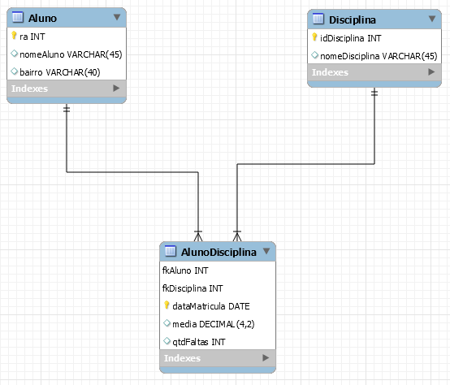

create database AlunoDisciplina;

use AlunoDisciplina;

create table Aluno (

ra int primary key auto_increment,

nomeAluno varchar(45),

bairro varchar(40)

) auto_increment = 1000;

create table Disciplina (

idDisciplina int primary key auto_increment,

nomeDisciplina varchar(45)

);

create table AlunoDisciplina (

fkAluno int, foreign key (fkAluno) references Aluno(ra),

fkDisciplina int, foreign key (fkDisciplina) references Disciplina(idDisciplina),

dataMatricula date,

primary key (fkAluno, fkDisciplina, dataMatricula),

media decimal(4,2),

qtdFaltas int

);

insert into Aluno values (null, 'Felipe Domke', 'Jardim Patente'),

(null, 'Reyel Soares', 'Sacomã'),

(null, 'Fernando Marques', 'Taboão'),

(null, 'Bruno Zapateiro', 'Sacomã');

insert into Disciplina values (null, 'CCO'),

(null, 'ADS'),

(null, 'REDES');

insert into AlunoDisciplina values (1000, 1, '2020-02-08', 8.60, 1),

(1000, 3, '2018-01-30', 7.40, 15),

(1001, 2, '2020-02-10', 10.00, 10),

(1001, 3, '2018-01-30', 9.50, 30),

(1002, 1, '2020-02-08', 7.50, 5),

(1003, 2, '2020-02-10', 8.00, 8);

**a)**

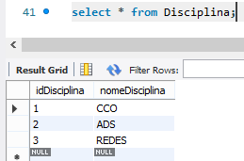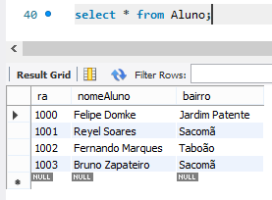

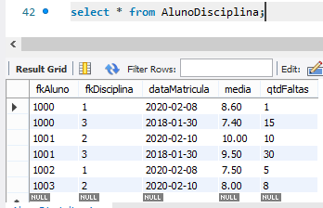

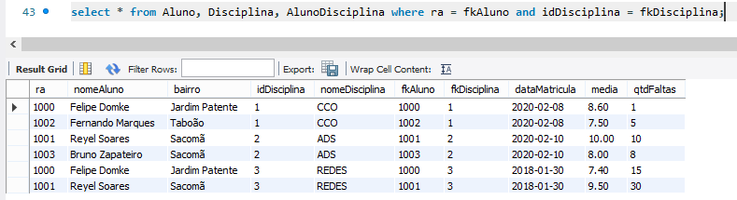**b)**

**c)**

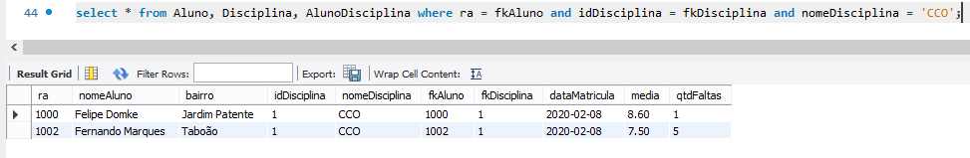

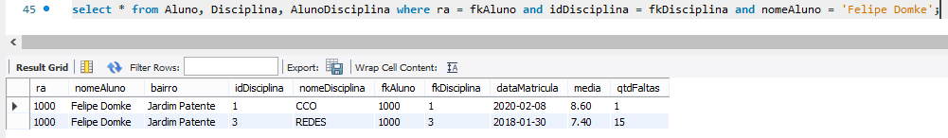**d)**

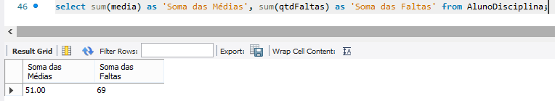**e)**

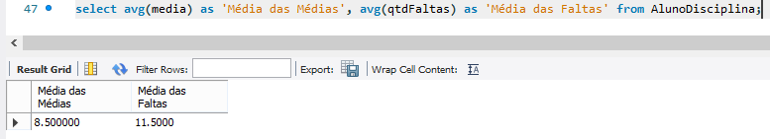**f)**

**g)**

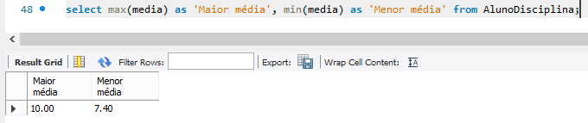

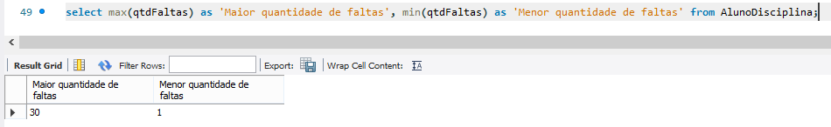**h)**

**i)**

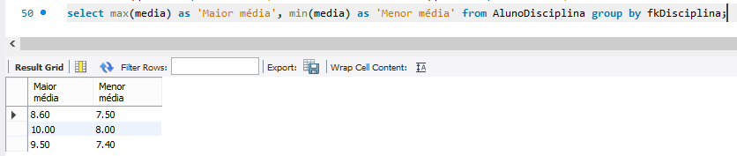

**j)**

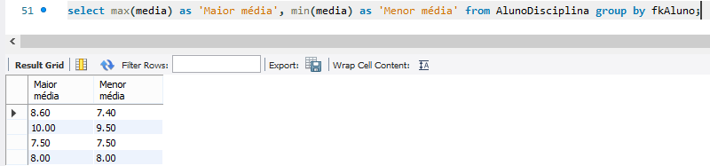

**k)**

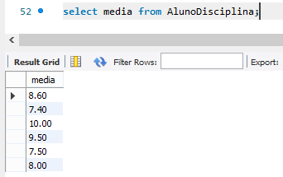

**l)**

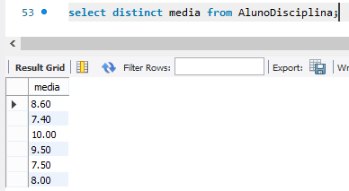

**m)**

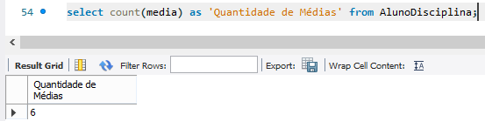

**n)**

